

8th Grade Supply List
2023-2024

Personal Supplies for all classes
- backpack (larger size; can have wheels if desired)
- several packages of loose-leaf notebook paper
- Pencils
- Ink Pens (small pack)
- 1-Three-Ringed Binder-1 ½ -2 in.
- Colored Pencils (small pack)
- Scissors (small pair)
- Glue Sticks (small pack)
- Dry Erase Markers (small pack)
- Post-it-Notes
- Ear buds (cheap pair is just fine.)
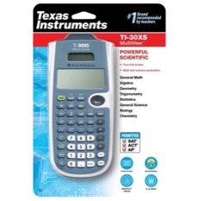
- TI-30XS Calculator (Optional – Provided in class)

Physical Science Only (high school course) –
- Calculator (Regular or Scientific)
- 4 oz White Glue

Algebra I Only (high school course)-
- TI – 84 plus (Optional)
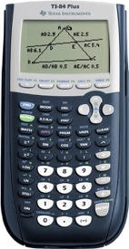

Supplies to be turned in to Homeroom Teacher: not required but very much appreciated.
- 2 boxes of tissues
- Paper Towels
- Hand Sanitizer
- Dry erase markers (small pack)
- 1 canister of disinfecting wipes

Please Note:
Other supplies may be requested by individual teachers after school begins.

